29/12/2023

Chakradhar Bhogapurapu, BIBA

Azure Databricks Day 2

We need to login the Azure account.

After logging in, we need to go into the create a work space and launch the workspace.

The below image shows the workspaces. I selected the 2nd work space. After clicking the workspace, we need to launch the workspace.

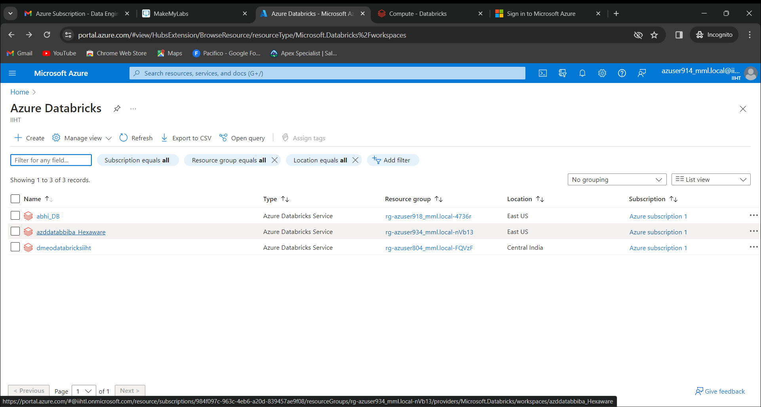

After launching the workspace, we will get to see some clusters that are already created.

To create our own cluster, we need to click on the “create compute” button.

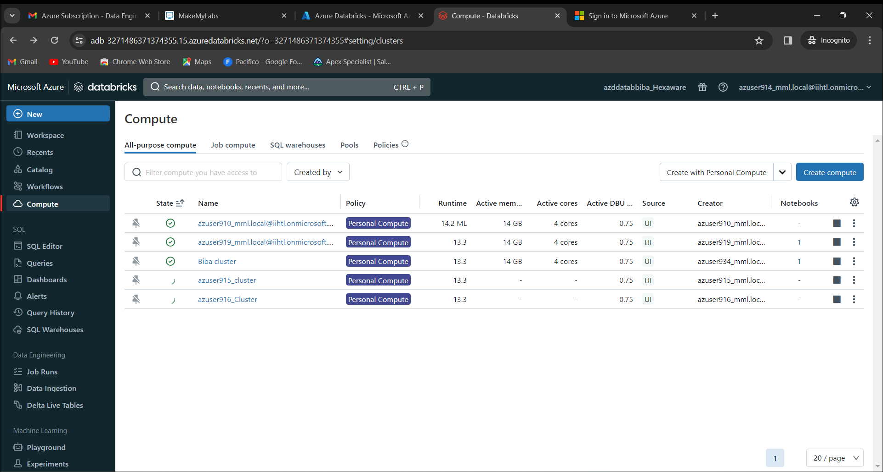

After clicking the “create compute” button, we get the page as shown below.

We can name the cluster as “azure914_Cluster”

Keep the policy as “Personal Compute”

Keep Single user access as “azure914_mml.local@iihtl.onmicrosoft.com”

Keep Databricks runtime version as “13.3 LTS (Scala 2.12, Spark 3.4.1)”

Keep Node type as “Standard_DS3_v22” that is 14GB.

Keep Terminate after 4320 minutes of inactivity.

Now click on the button “create compute”

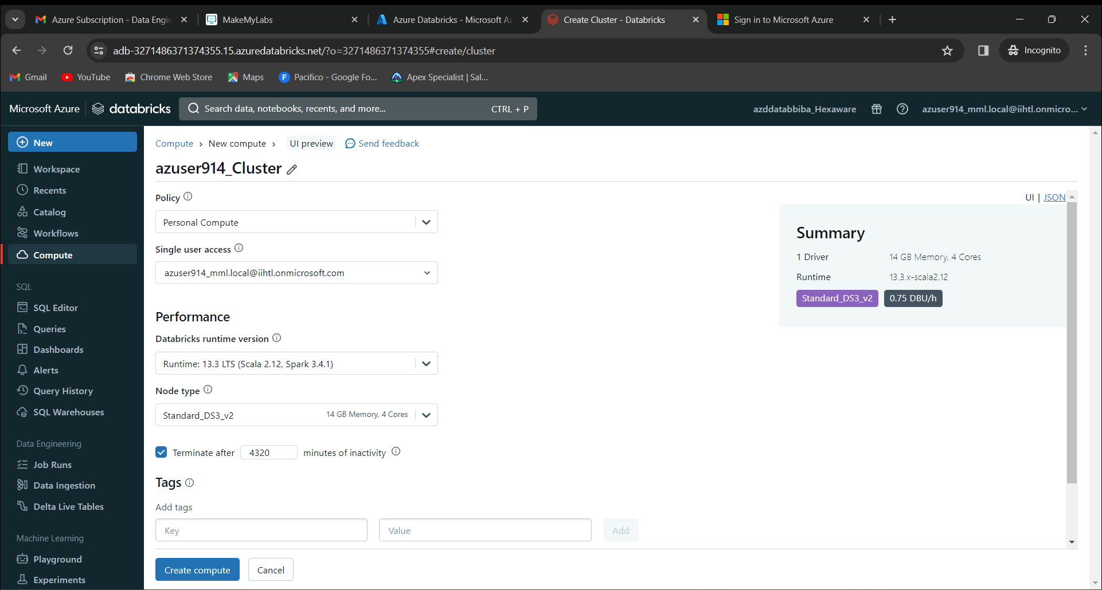

Now we get our new cluster as “azure914_Cluster”

Click on the cluster that we created.

Now we click on the “New”

Now click on “Notebook”

Now we can see the Azure databricks Notebook.

We get the image as below.

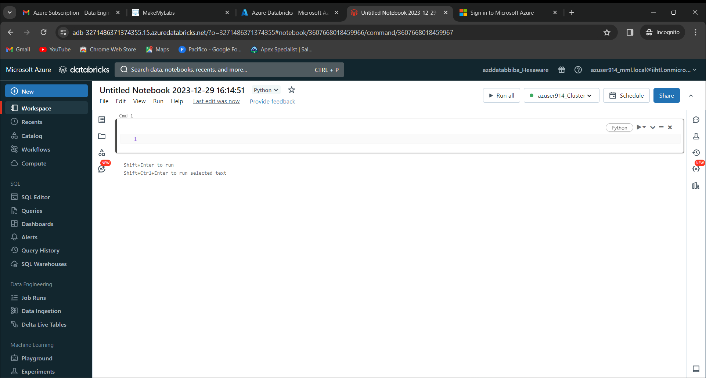

Now we will run the programs and see if they will execute properly or not.

We must connect the created notebook with the cluster that we created.

Now we will see some programs running and getting output.

Program 1:

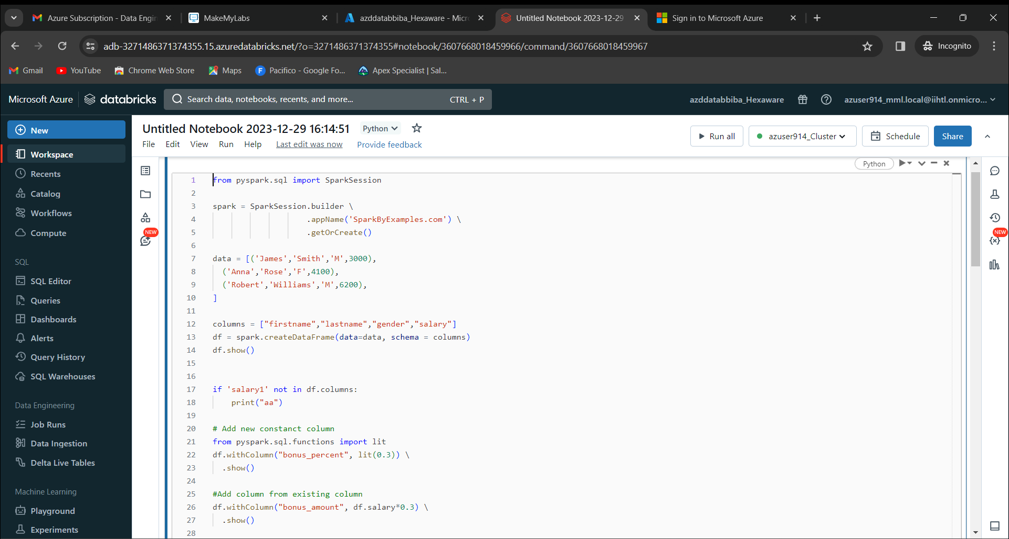

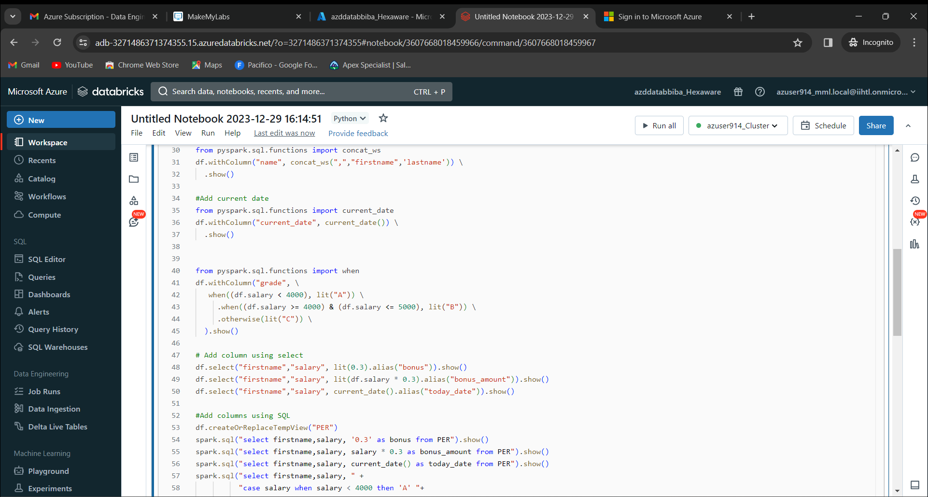

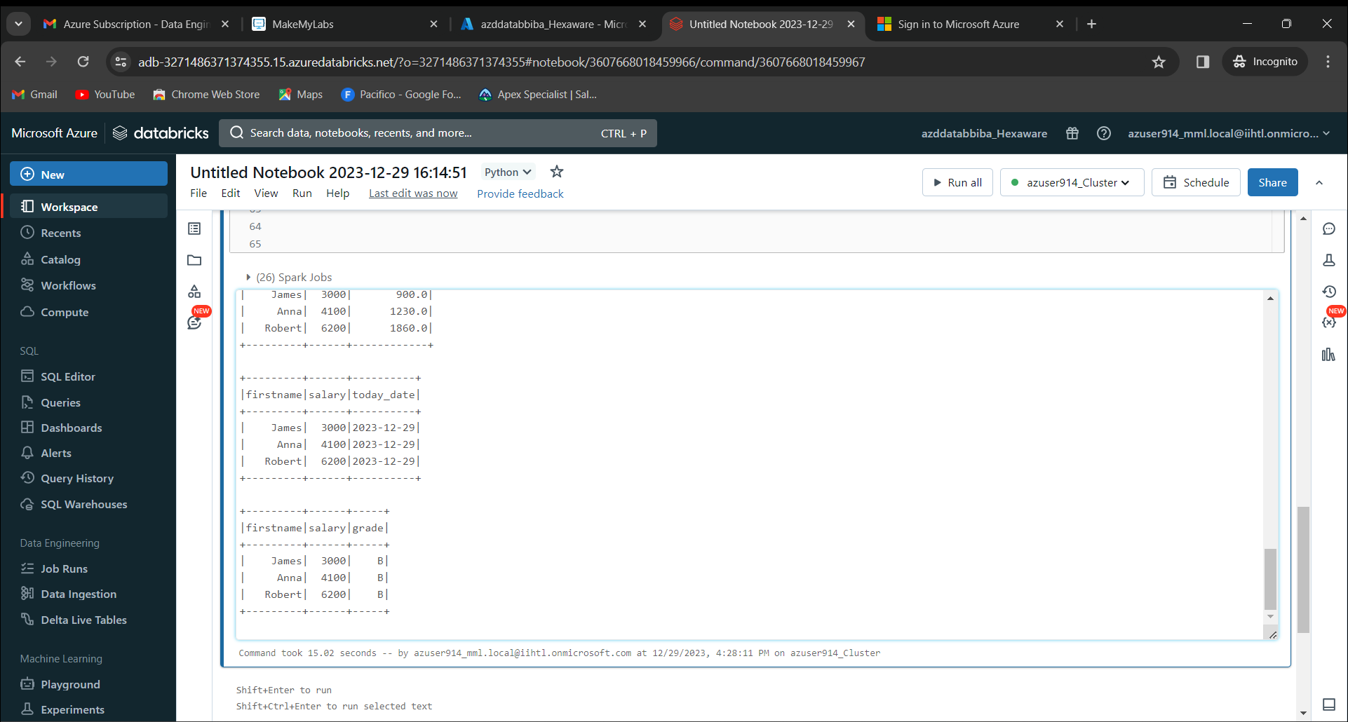

Program 2:

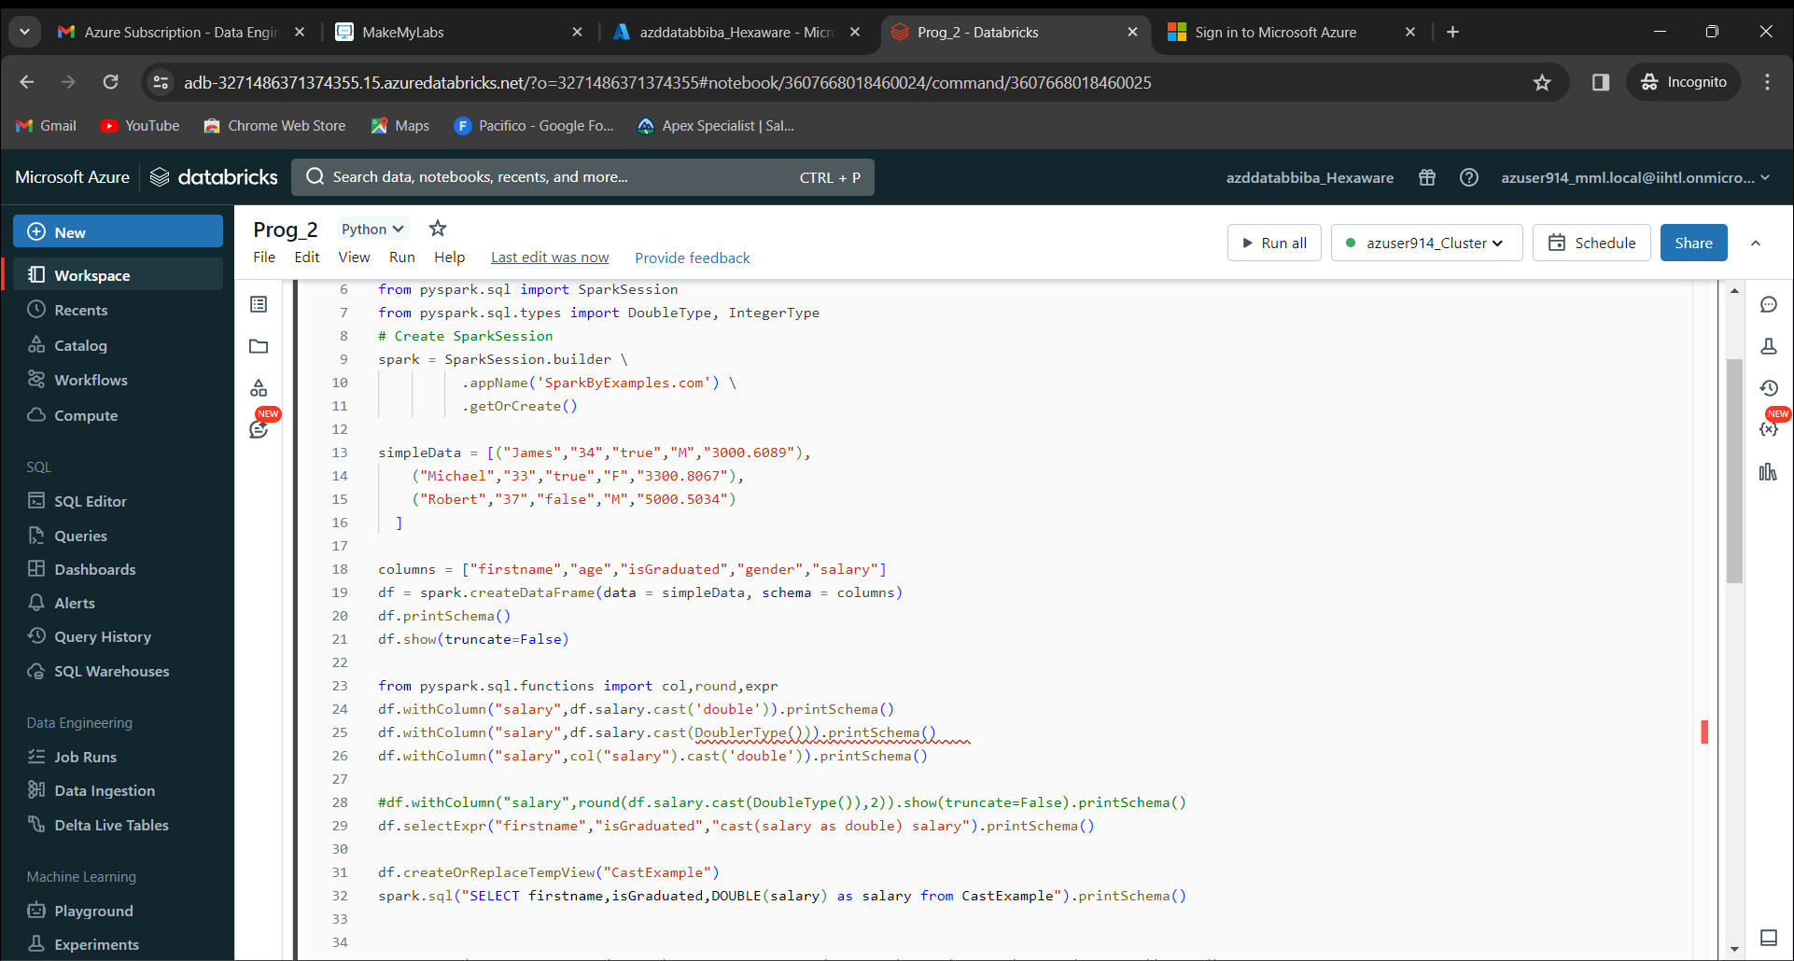

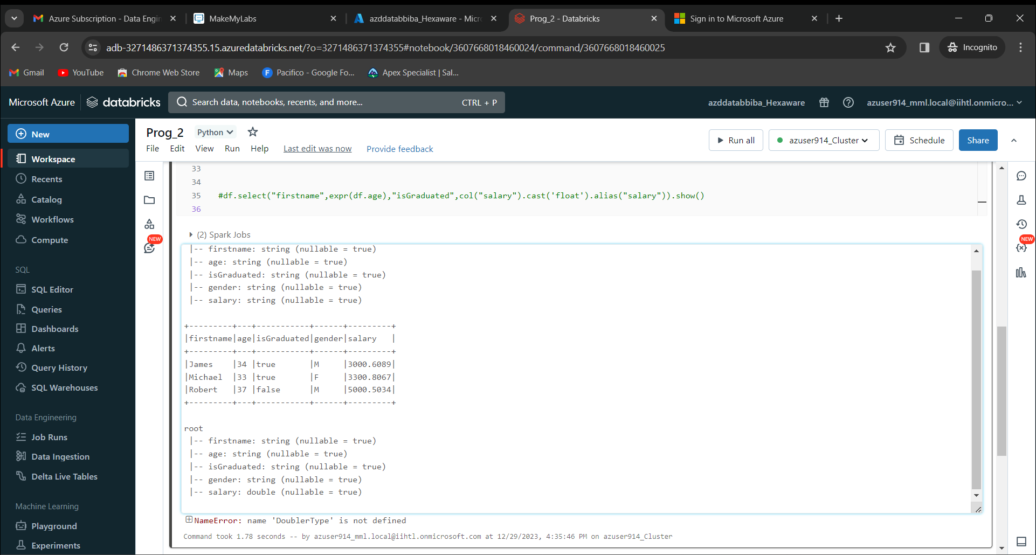

Program 3:

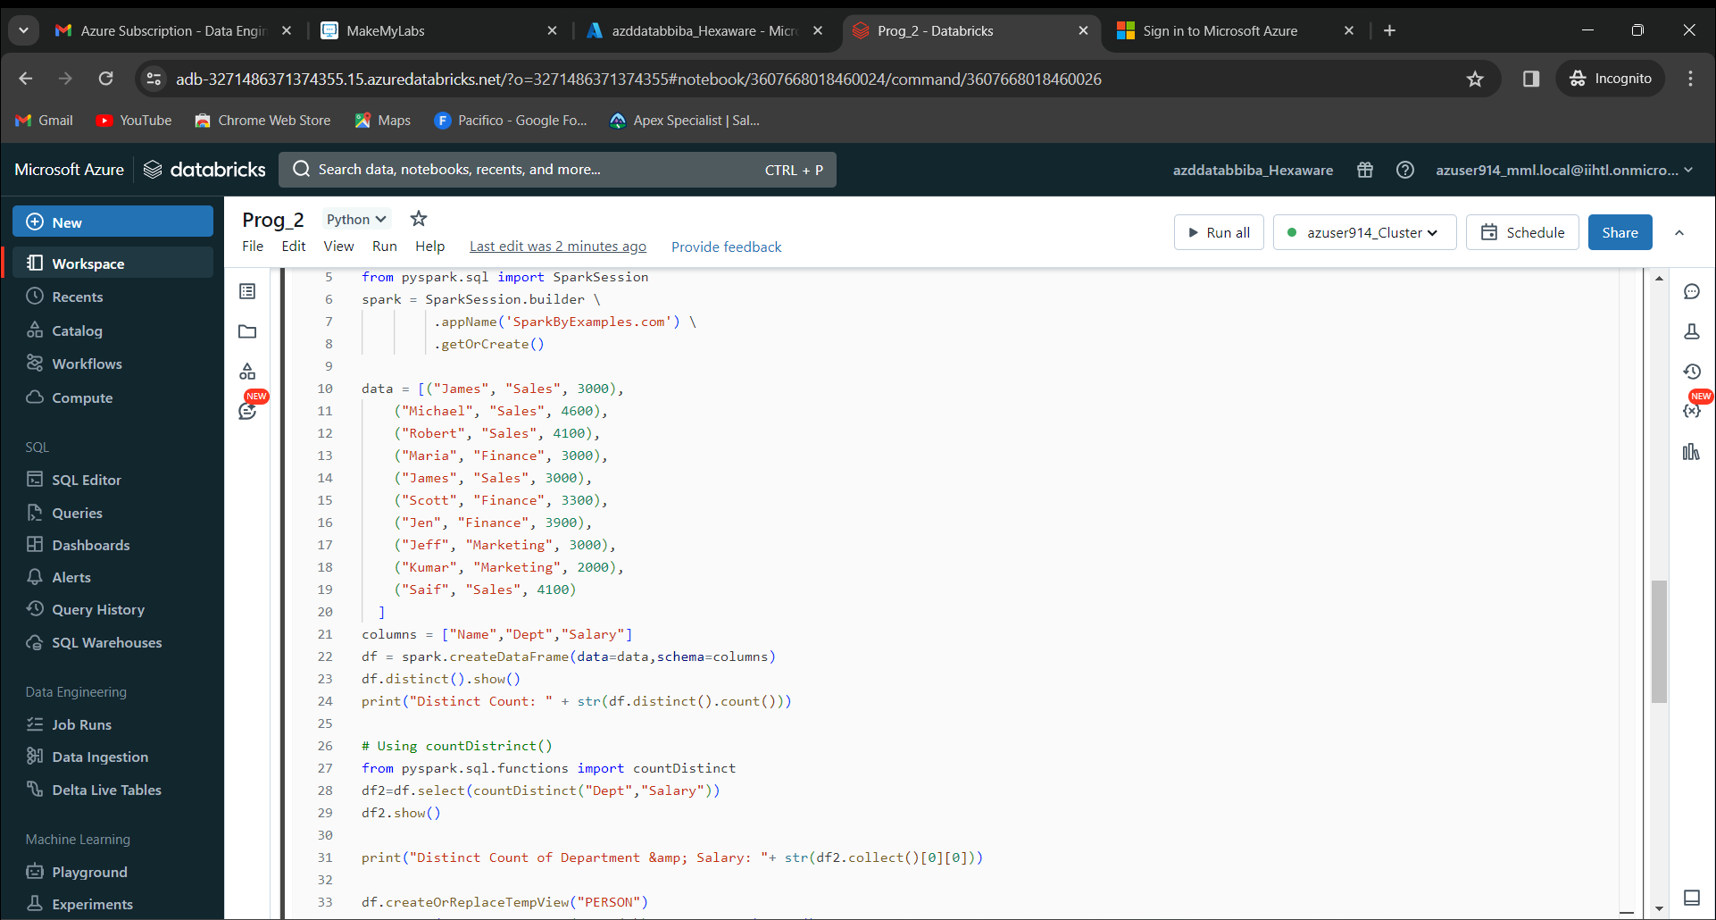

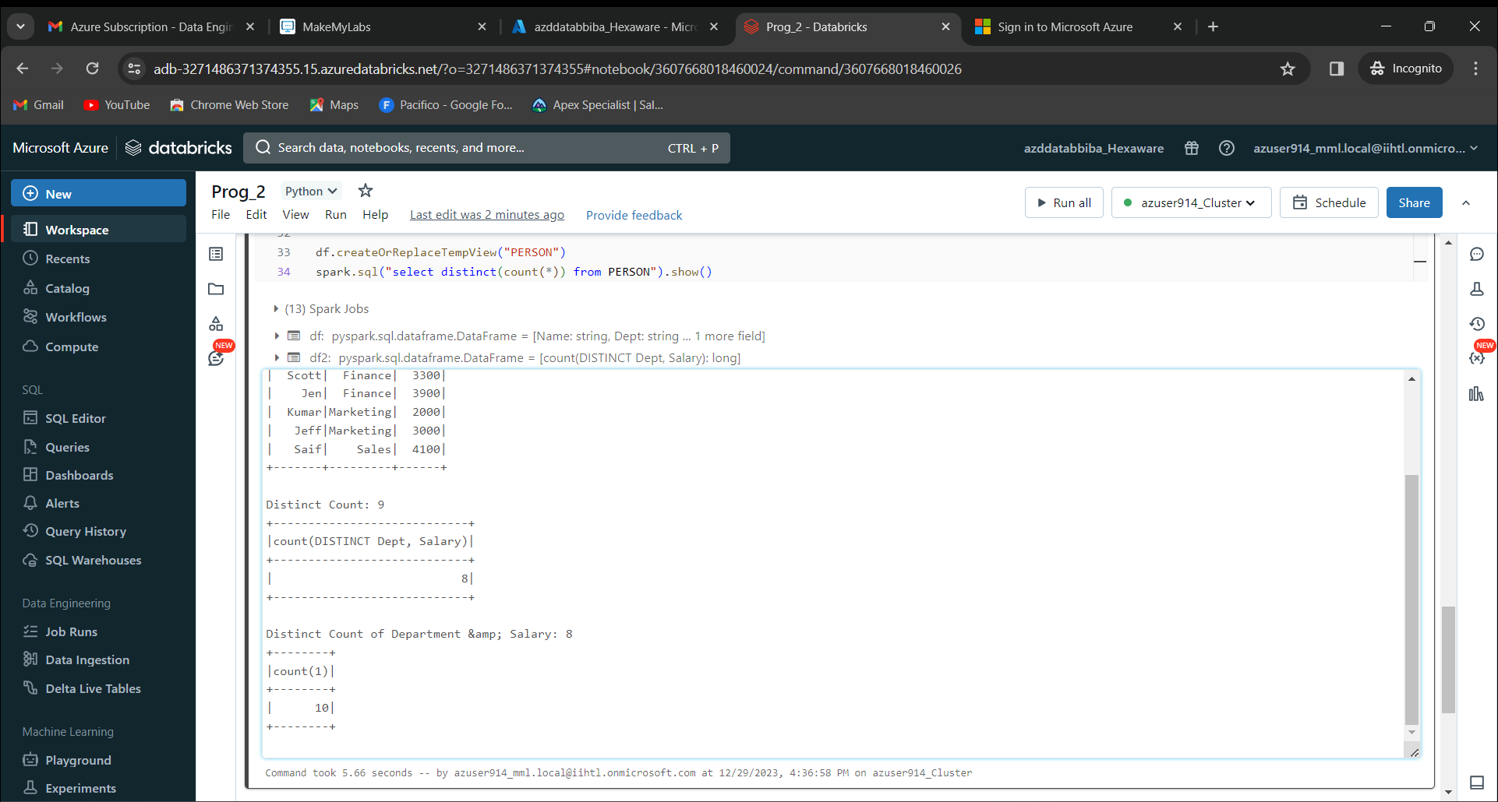

Program 4:

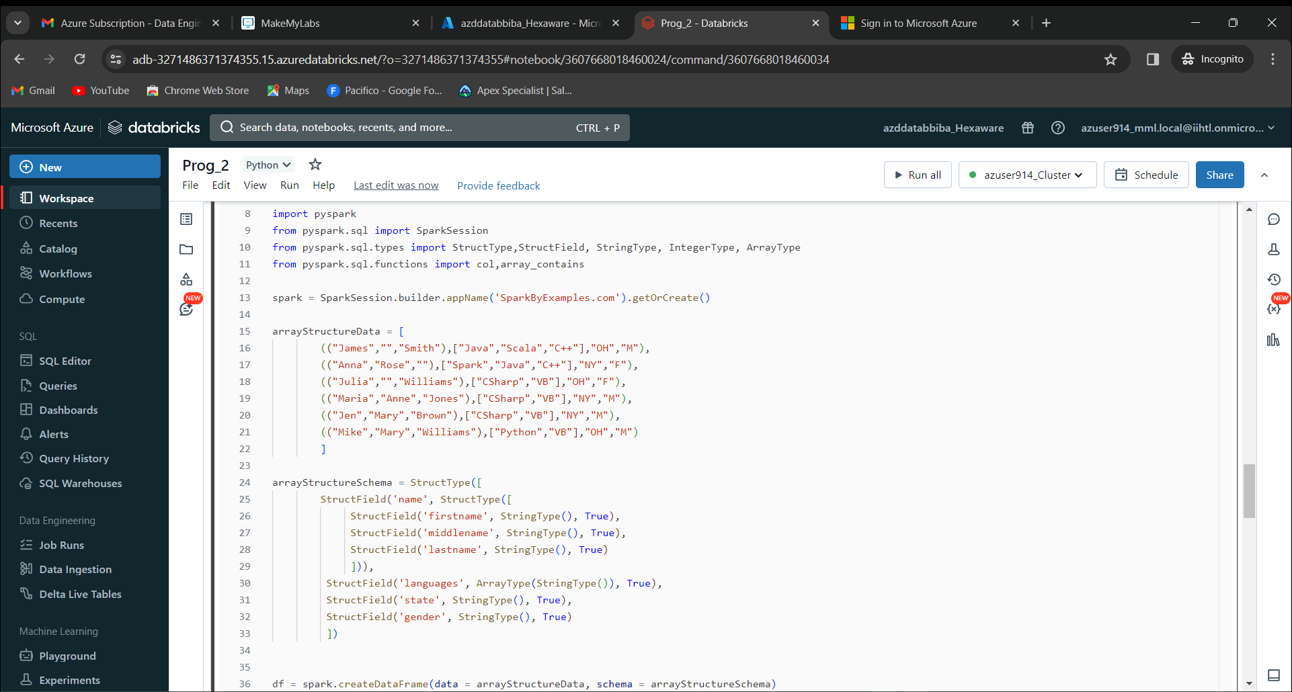

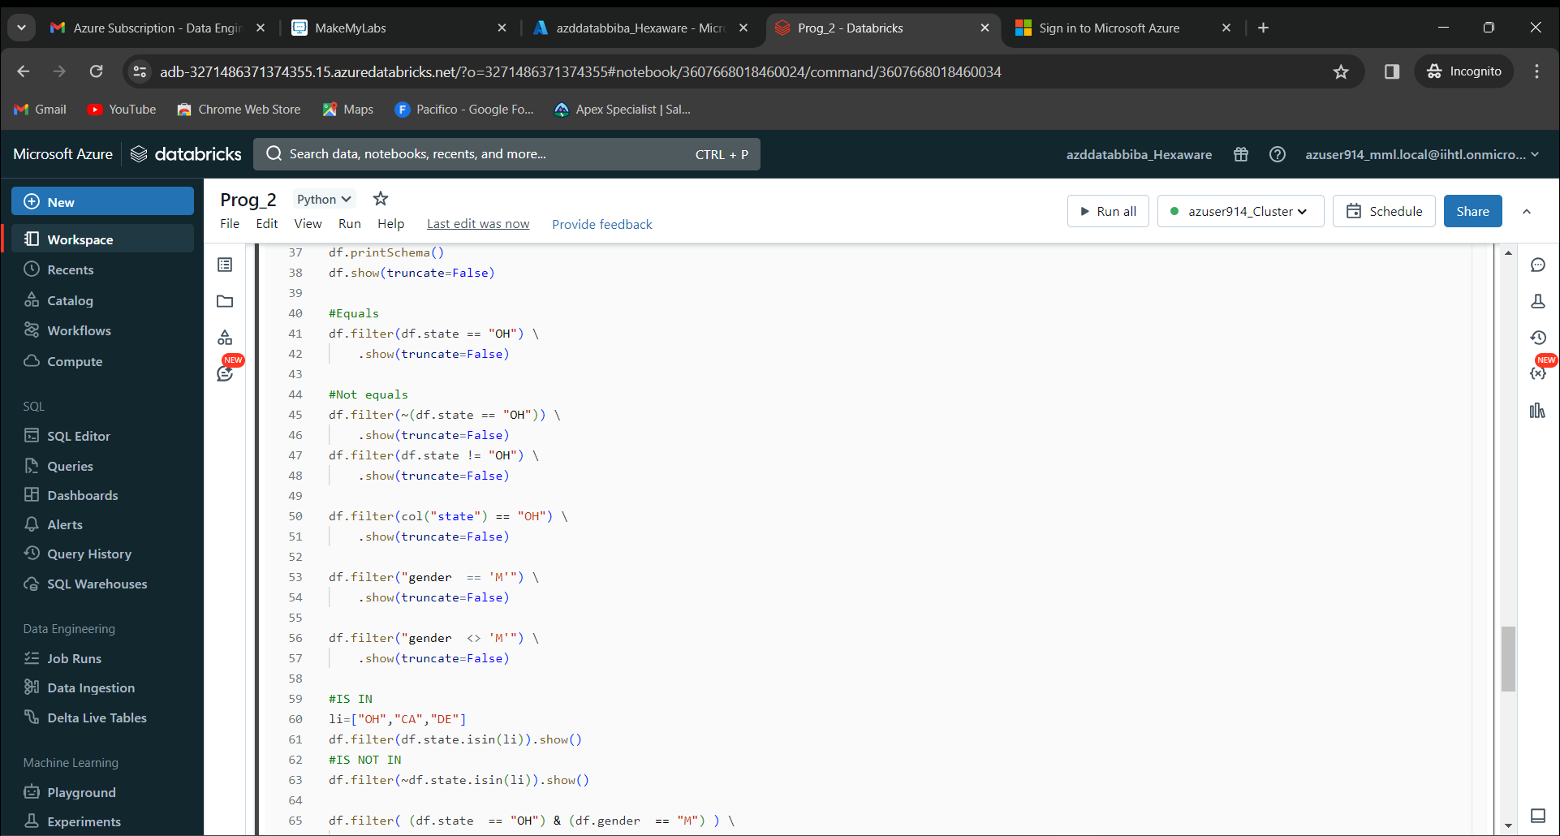

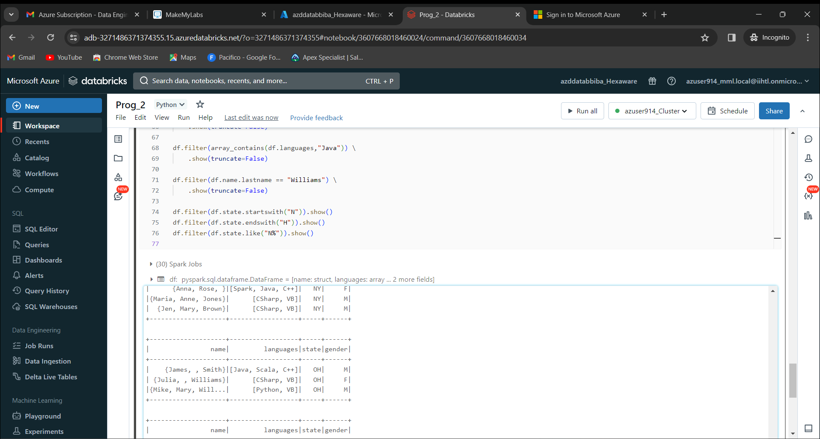

Program 5:

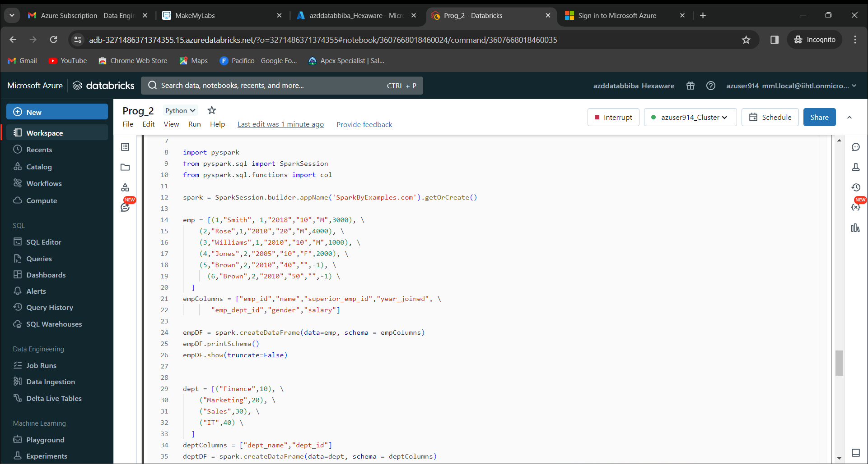

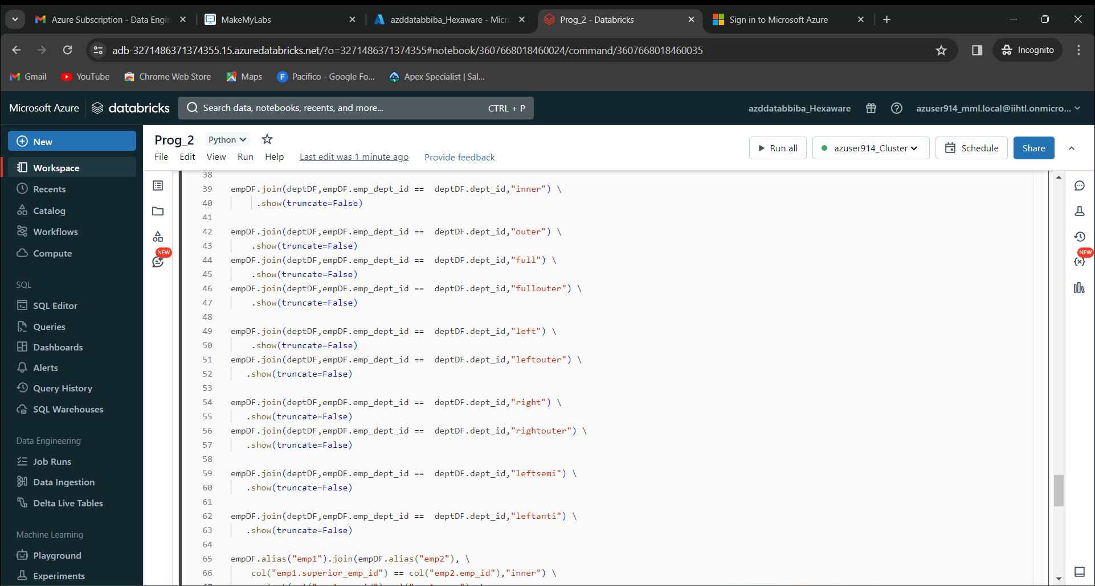

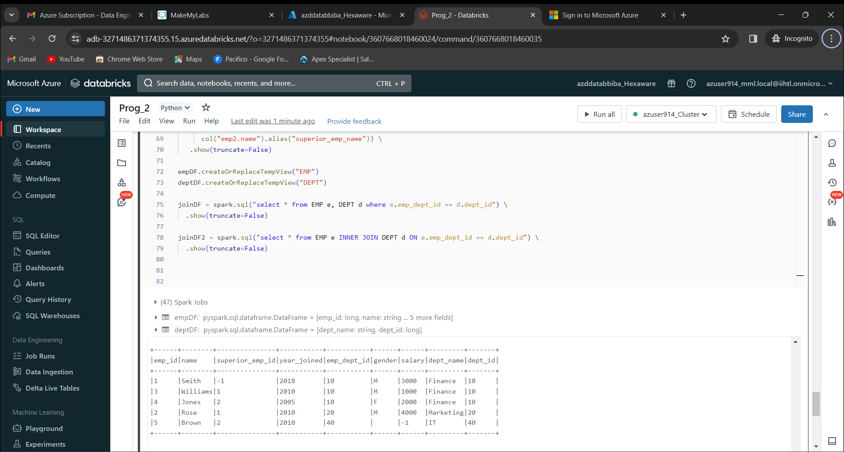

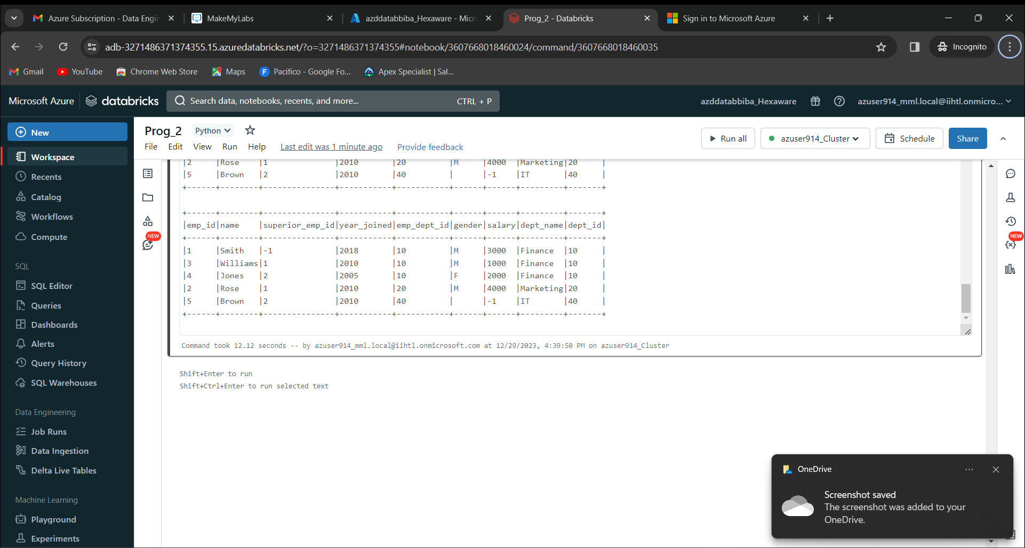

Program 6:

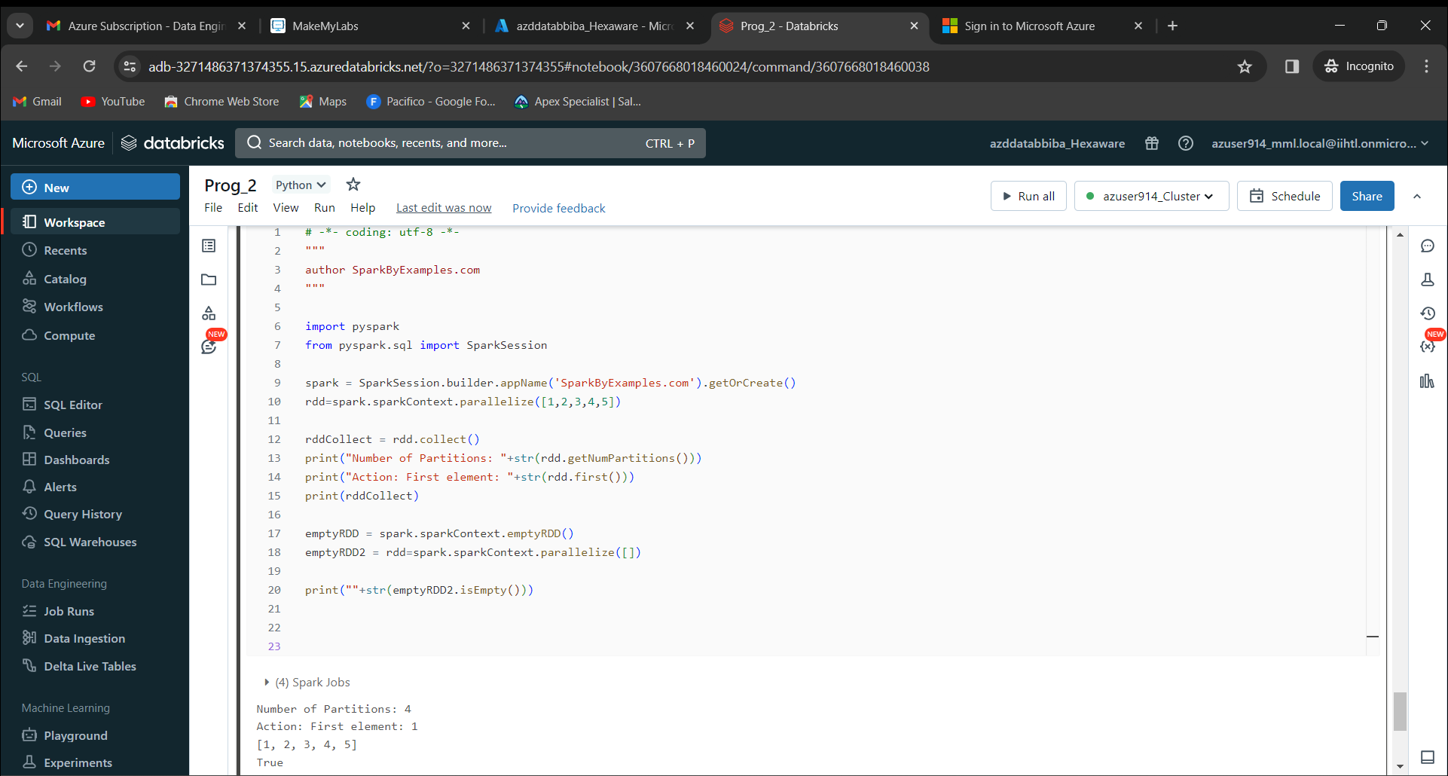

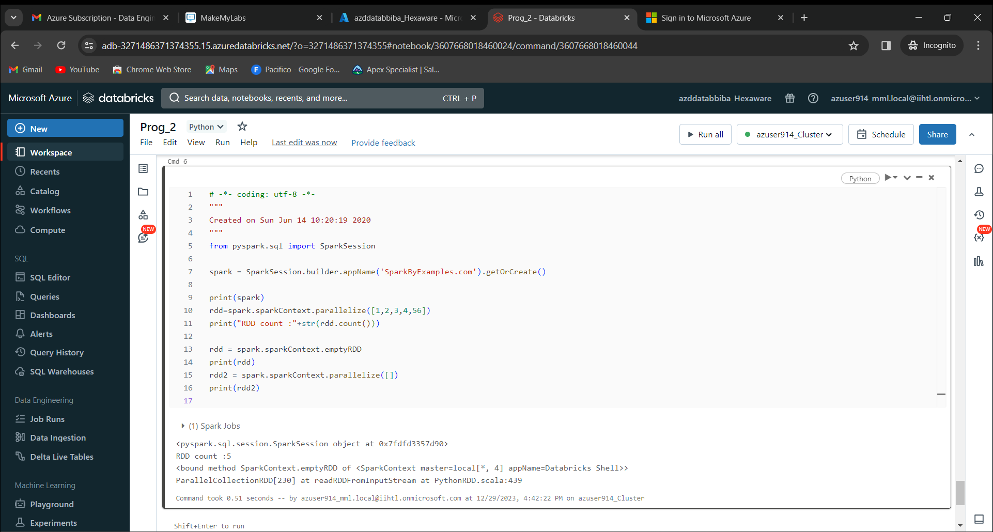

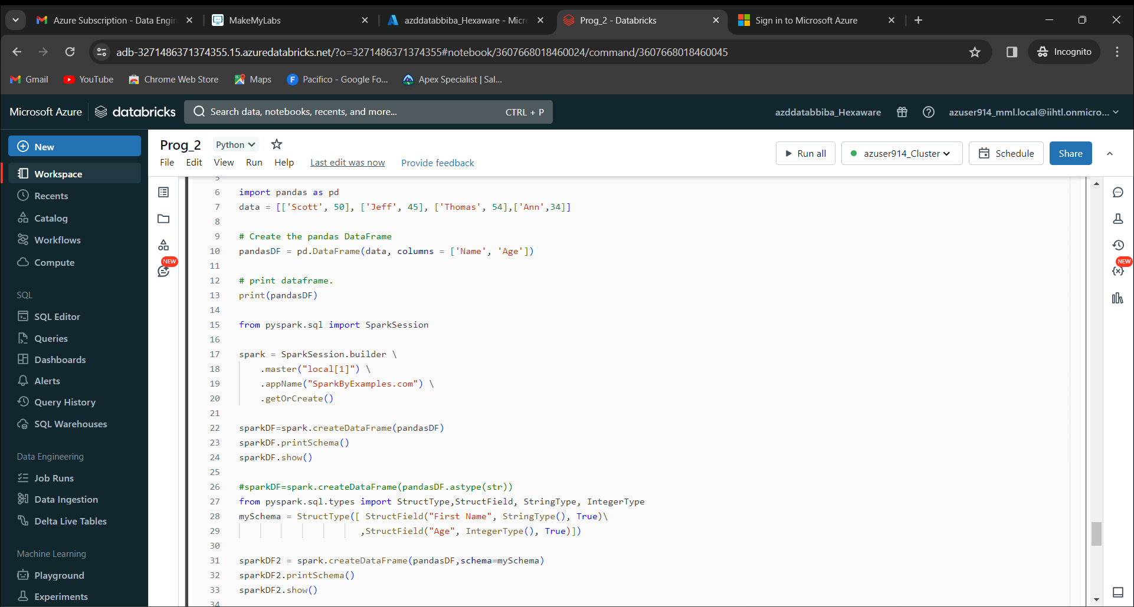

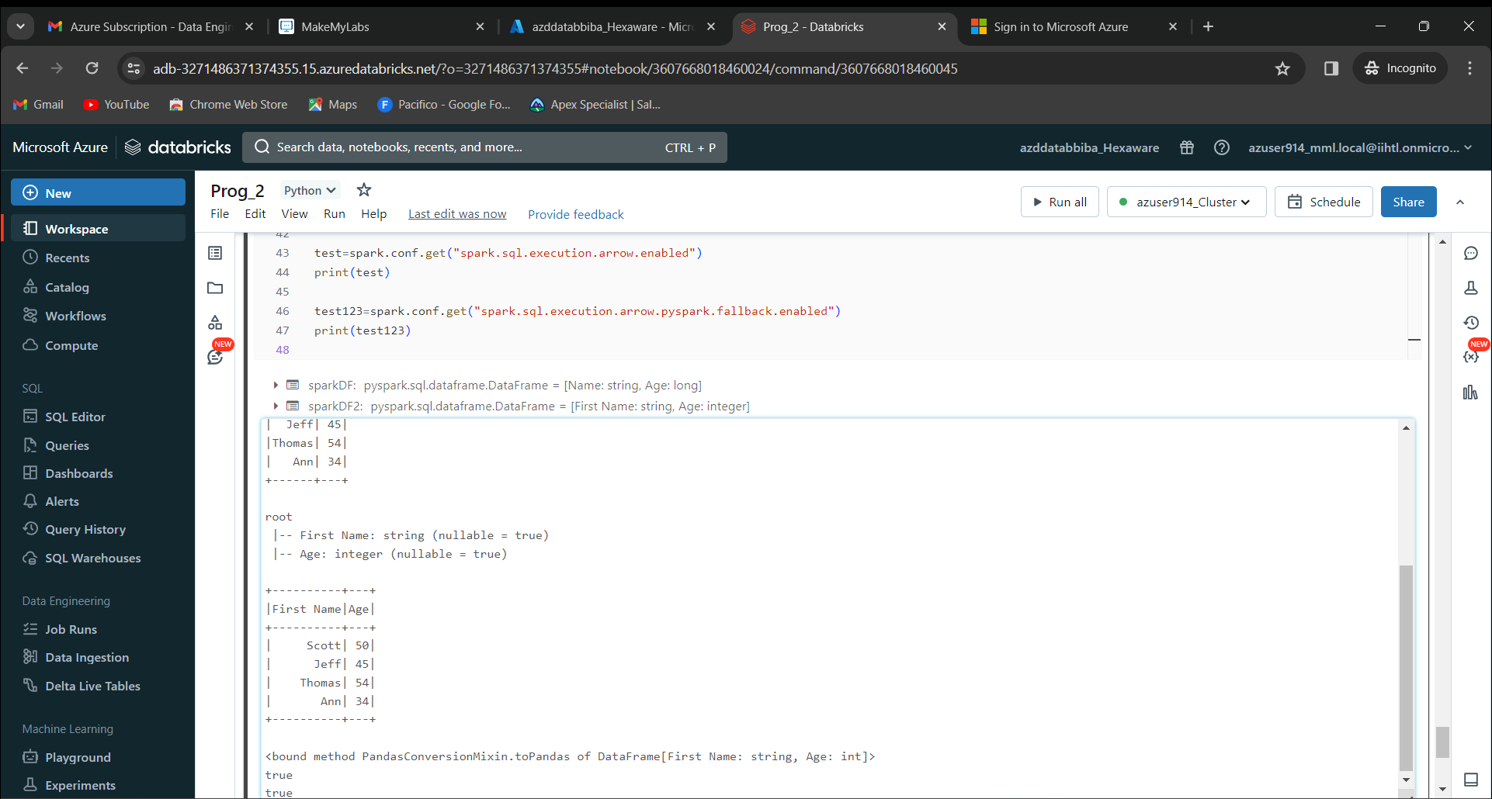

Now we can disconnect our created notebook with the cluster.

Now we can terminate the cluster and delete it.